**

**GUILDHALL SURGERY AND PPG NEWSLETTER**

**AUTUMN 2023**

**CLINICAL UPDATE**

The surgery is excited to welcome the following new staff members:-

* Martin Warwick – Assistant Practitioner
* Emma Milk – Mental Health Social Worker
* Ann McGinn – Care Navigator / Receptionist
* Natalie McLoughlin – Care Co-Ordinator (Social Prescribing Team)
* Chelsea Warden – Social Prescriber

We are also pleased to advise that a couple of our team members are moving on to better and greater things, still within our Primary Care Network. We would like to congratulate Jenna Radford for securing the post of Digital Lead and Kayleigh Grey, moving into a Care Co-Ordinator role. We wish them all the very best for the future and thank them for the contributions to the surgery in previous years.

**APPOINTMENTS / URGENT APPOINTMENTS**

Our care navigators / reception team will continue to triage appointment requests and ask you for a description of your symptoms; **THIS IS AT THE GP’S REQUEST** and will assist in enabling them to provide you with the right appointment and treatment with the most appropriate member of our clinical team.

**Please note** that if you need to act on behalf of another person or discuss their care with us, we will need ‘Data Protection & Patient Health Record Information’ form completed by the person *and* witnessed by a 3rd party. The form is available in the ‘Further Information’ section of our website or a copy can be collected from reception. **Without** consent on an individual’s Health Record, **NO** members of our team will be able to disclose information or discuss patient care.

**WEBSITE**

Please visit our website for a host of additional information, forms and links:-

Details on how to register for GP online services, the NHS app can be used to view your medical information, request medication as well as making appointments.

If you have a health concern / medical condition and wish to receive advice, guidance or treatment, you can always send us an ‘E’ consult request (see icon). This is especially useful for repeat medical certificates (i.e. sick notes).

**HOME VISITS**

If you are housebound and require a home visit, then it is important that you telephone the surgery **BEFORE 11AM**. You will still be asked for a description of your symptoms and in some cases a clinician may also telephone you prior to a visit for further details.

**LONG TERM CONDITIONS**

If you have diagnosed long term condition/s (e.g. arthritis, asthma, diabetes, epilepsy, angina, heart failure, high blood pressure), the surgery will be in touch to make an appointment for your annual review (by month of birth order). In some cases, blood test results will be required prior to the review and if necessary, a blood test form will be provided to enable you to book directly.

**IMPORTANT – MEDICATION REVIEWS**

For patients on regular medication, it is really important you have an annual review with one of our nurses or clinical pharmacist team. This is to ensure your medication is current and up to date and enable you to continue to request repeat prescriptions. If you have not had this appointment please be aware that your prescription request may be delayed. You may also be required to have an annual blood test before this appointment. When booking please advise the prescribing or reception team the date your blood test has been booked for so they can arrange your review following this. (The date your medication review is due is shown on your repeat prescription form/s.)

**INFECTION CONTROL**

We request that if you have COVID symptoms please DO NOT attend the surgery. Please also advise our reception team if booking an appointment.

**HOT TOPIC** *by**Katy Cowling, Lead Practice Nurse*

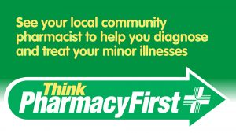As autumn approaches the surgery prepares for the onslaught of winter pressures and the increase of coughs, colds, sore throats and respiratory infections. The majority of these are caused by viral infections and do not require antibiotics or a GP visit and are self-limiting after a few days. In the first instance please do seek advice from your local pharmacist.

**Covid-19**

Many of you may have seen on the news that cases of covid-19 are increasing and there has been another mutation and strain circulating, a descendant of Omicron, dubbed "Eris".

Guidance from the government and NHS regarding infection control measures in the surgery have not changed but we urge all patients to be vigilant with their hand hygiene; hand gel is still available in reception. At any time in the waiting room we may have elderly patients or those people with a weakened immune system, so if you have any of the below symptoms we ask that you please **DO NOT** attend the surgery and instead request a telephone appointment.

COVID-19 symptoms can include:

* a high temperature or shivering (chills) – a high temperature means you feel hot to touch on your chest or back (you do not need to measure your temperature)
* a new, continuous cough – this means coughing a lot for more than an hour, or 3 or more coughing episodes in 24 hours
* a loss or change to your sense of smell or taste
* shortness of breath
* feeling tired or exhausted
* an aching body
* a headache
* a sore throat
* a blocked or runny nose
* loss of appetite
* diarrhoea
* feeling sick or being sick

<https://www.nhs.uk/conditions/covid-19/covid-19-symptoms-and-what-to-do/>

**Influenza & Covid 19 vaccination Clinics**

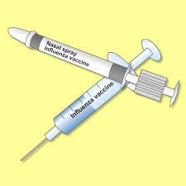We have successfully held two Covid/ & flu clinics at The Old School hall for our patients and additionally Glemsford and Wickhambrook patients. The total number of bookings were 1785! Unfortunately, we also had people that did not attend (DNA) and these accounted for 11% of the bookings (191).

Once again, our staff and volunteers did a fantastic job and we would like to thank everyone involved, for their preparation, professionalism and for giving up their Saturdays to enable the clinics to go ahead.

We will be looking at a small catch up clinic for those that still need the vaccines and we will be in contact as necessary.

<https://www.nhs.uk/conditions/vaccinations/flu-influenza-vaccine/>

Children aged 2 and 3yrs (before 31st August 2023) will be called for their nasal flu vaccination at the surgery, as well as those aged between 6 months to 16yrs old with an underlying health condition, children at school will be offered this through their school. Children in other age groups with no underlying health condition, are vaccinated through the schools immunisation service at their schools, so you need to wait to hear from your child's school about when they plan to vaccinate their pupils. For more information see:

<https://www.nhs.uk/conditions/vaccinations/child-flu-vaccine/>

**Suffolk**

Suffolk Community and School Age Immunisations Service  
Telephone Number: 0300 555 5055 (Option 4) – 8m to 4pm  
Email: [hct.csaissuffolk@nhs.net](mailto:%20hct.csaissuffolk@nhs.net)  
Follow us on Twitter: [@SuffolkImmsTeam](https://twitter.com/suffolkimmsteam?lang=en)

**Pneumonia vaccination**

Everyone over 65yrs of age and those with certain underlying medical conditions will be called for a pneumonia vaccination.

**Shingles vaccination**

From the 1st September a new Shingles vaccination programme started which means all of those eligible will be receiving a two dose course of vaccination. This is different from previous years due to a change in the vaccination we use. **Those who have received a previous dose of shingles vaccine** **do not require any more**.

The programme is being rolled out in stages based on age groups and to those who have a lowered immune system. We will be calling in patients for this and will be doing this in a systematic way to allow for the allocated and restricted amount of vaccinations we can order at a time. See below:

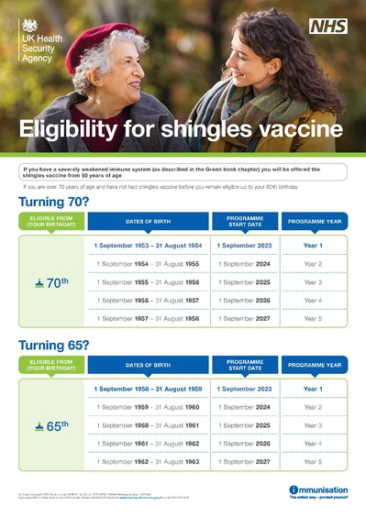

Everyone aged between 70 and 79 years is eligible for the shingles vaccine up to 79 years of age. Those who turn 70 from 1 September 1953 – 31 August 1954 will receive their vaccination this year (**Year 1** 1st September 2023- 31st August 2024).

If you are 65, you are also eligible for your shingles vaccine. Those who turn 65yrs from 1 September 1958 – 31 August 1959 will receive their vaccination this year (**Year 1** 1st September 2023- 31st August 2024).

If you have a severely weakened immune system you will be eligible for shingles vaccine from 50 years of age.

**Dementia**

As a surgery we recognise that many of our patients have Dementia, Alzheimer's or some other cognitive disability. Therefore we arranged an assessment of the surgery by Sue Ryder Dementia together.

***"Dementia Together****, led by Sue Ryder takes a community asset-based approach working in partnership with a number of organisations. These include statutory services, the voluntary sector and local community groups, with a view to simplifying the pathway for people needing support, making the most of and building on support available and encouraging growth in local support and information available."*

You may have seen that we now have signs printed in yellow and a rather striking red toilet seat. These were suggestions by Sue Ryder to make signage and equipment more user friendly for those with dementia. The flooring that we replaced is also deemed as dementia friendly as are the different paint colours we have used in rooms.

As you can all imagine our listed, old building can be a challenge when looking at access and being more disability and dementia friendly but many of our recent refurbishments have taken these needs into consideration. We are always working on this within our unique building limitations.

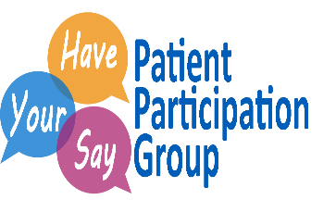Our **PATIENT PARTICIPATION GROUP (PPG)** helps to communicate to us the views and perceptions from our patients of the services that we provide as well as ideas about how we could improve our service. Our Facebook page is very active and we are making it more interactive. We always have feedback surveys in the surgery in paper form, which can be completed when you next come into us. We also like to encourage our patients to visit the Facebook and Website for information and updates regarding the surgery and general health information and news.

**PRESCRIPTION REQUESTS**

If you wish to order repeat medications, you can do this by requesting in writing and posting in the surgery post box by the side entrance. Alternatively, you can order your repeats online, once you have registered at Reception for on-line access.

Please note that we will still need at least 2 working days before your medication will be ready for you to collect at your nominated pharmacy.

**PRESCRIPTION QUERIES**

If you have a query regarding your prescription or medication please call our dedicated PRESCRIPTION LINE. The line is open between 10:00 and 13:00 each working day. Alternatively, you can leave a message on their answering service and they will call you back. Please DO NOT direct prescription queries to our reception team as they will not be able to help you.

**SAMPLES**

If you have been asked by one of our team to supply a urine, stool, sputum sample etc., please ensure these are back to the surgery before 11:00am.

**USEFUL INFORMATION**

Contact Times:-

|  |  |
| --- | --- |
|  | Monday - Friday |
| Opening Times | 08:00 – 18:30 |
| Surgery Times | 09:00 – 12:00 & 15:30 – 18:00 |
| Reception Telephone Lines | 08:30 – 13:00 & 14:00 – 18:30 |
| Prescriptions | 10:00 – 13:00 |
| Secretarial / Reports | 14:00 – 16:00 |
| Test Results | 15:00 – 17:00 |

**Integrated Care Board (ICB) Training Events / Surgery Closures**

The Surgery will be **CLOSED** on the following day & times:-

* 12:30pm Thursday 23rd November 2023 until 8:00am Friday 24th November 2023

We apologise for any inconvenience this may cause and thank you for your patience.

If you need advice for any minor ailments, please see your local Pharmacist.

If you require urgent medical attention, please contact 111.

If you have a life threatening medical emergency please call 999 immediately.

Useful Websites:-

|  |  |
| --- | --- |
| Guildhall Surgery website | [www.guildhallsurgery.co.uk](http://www.guildhallsurgery.co.uk) |
| Find us on Facebook | <https://en-gb.facebook.com/GuildhallsurgeryClare/> |
| Government COVID 19 | <https://www.gov.uk/coronavirus> |
| Flu injections | [www.nhs.uk/conditions/vaccinations/flu-influenza-vaccine/](http://www.nhs.uk/conditions/vaccinations/flu-influenza-vaccine/) |

***With best wishes,***

***The Guildhall Surgery Team***